Methodology for measuring and estimating funding to data and statistics

Contents

Context 2

Accurately monitoring funding to statistics 2

Reducing the lag 5

What is the reporting lag? 5

Estimating up-to-date support to statistics using CRS 6

Nowcasting: using commitments to predict current disbursements 7

Forecasting: using assumptions to predict future disbursements 9

Expanding the PRESS database 10

Exploring alternative data sources for aid flows on statistics 10

The International Aid Transparency Initiative (IATI) 10

Donors’ transparency portals 10

Multilateral donors’ prospective reporting to the PRESS survey 11

Addressing gaps in the alternative data sources 13

Linking the alternative sources: the new harmonised database 14

Bringing them together – nowcasting and forecasting with the new harmonised database 15

Conclusion 15

References 21

## Background

PARIS21 produces the Partner Report on Support to Statistics (PRESS) annually to report on trends in support to statistics. The methodology is applied retrospectively for all previous years to ensure comparability over time. This document presents the methodology.

## Monitoring funding to statistics with accuracy

This section provides information on how to monitor support to statistics and how the accurate data of the PRESS report, which is also used for reporting SDG indicator 17.19.1 (“Dollar Value of all resources made available to strengthen statistical capacity in developing countries”), is generated.

The PRESS report aims to provide a full picture of international support to statistics. To achieve this goal, it mainly takes advantage of two data sources:

***OECD’s Creditor Reporting System***

1. The first is the Organisation for Economic Co-operation and Development (OECD)’s Creditor Reporting System (CRS), which records data from OECD Development Assistance Committee (DAC) members (donors) and some non-DAC donors. This provides a comprehensive account of Official Development Assistance (ODA). Donors report to the CRS using specific codes for the sectors targeted by their aid activity. The Statistical Capacity Building (SCB) is designated by the sector code 16062.[1] However, when statistical capacity building is a component of a larger project, it is not identified by this code, which causes the CRS figures to misestimate actual levels of support for international aid. PARIS21 is seeking to reduce this usually downward bias using a text analysis methodology (see Box 1).

Box 1. Identifying data and statistical projects in CRS using text analysis

**Step 1: Filtering project titles**

Firstly, PARIS21 uses text analysis to search through project titles using a keyword list that contains statistical terms such as *census, survey, data, indicators, etc.* Because the project titles are usually concise, those which contain any of these keywords are identified as data and statistical projects.

**Step 2: Filtering project descriptions (short)**

Secondly, using a similar approach, PARIS21 searches through the short descriptions using a stricter keyword list, which contains terms such as *SDG data collection, census preparation, capacity development, etc.* This list is used to avoid “false-positive” descriptions that only mention data or statistical concepts for reference.

**Step 3: Double-checking false positives and blacklist**

Similarly, throughout the first and the second steps, another list of keywords (a “blacklist”) is also used to avoid the identification of projects that are almost certainly not related to data and statistics. The most common example here is the landmine survey in conflict regions.

This process also helps to eliminate some monitoring programmes that do not contribute to the improvement of capacity in recipient countries, but which have been mistakenly marked as 16062 by reporters. However, for projects that have no or very simple descriptions, these mistakes may still lead to “false positives” in the PRESS dataset.

**Step 4: Filtering project descriptions (long) using machine learning**

Thirdly, the projects identified in the first and second steps are combined with projects identified through the SCB purpose code. The machine learning approach is then used to summarise the key features of long descriptions in identified projects. The long descriptions of the rest of the projects are then compared against the identified features. Only descriptions that bear significant similarities with the identified projects will be marked as data and statistical projects.

The CRS identifies a project donor by looking at the source of the funding. Countries are identified as donors if the flow is directly between them and the recipient country (type 1 in Figure 1), or if the flow is earmarked for a certain project and channelled through multilateral organisations (type 3 in Figure 1). If a project is funded by un-earmarked core contributions to multilateral organisations, the donors are marked as the multilateral organisations (types 2 and 4 in Figure 1).

Figure 1. Flow of official aid in CRS

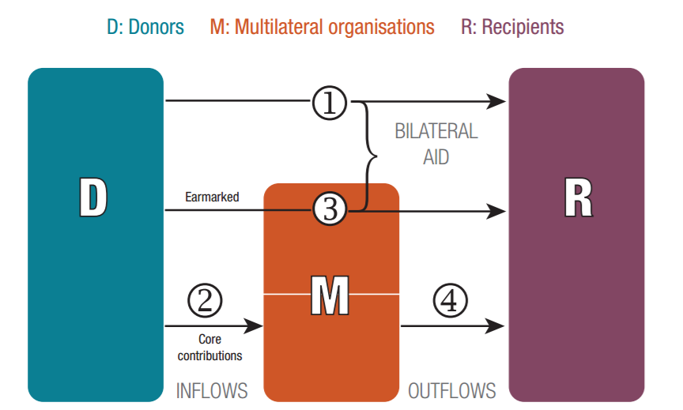

***PARIS21’s annual online survey***

1. The PARIS21 Secretariat supplements the data from the CRS with an annual online survey, which is completed by a global network of respondents, mostly non-DAC donors. The survey covers a subset of the variables collected in the CRS, as well as some additional variables specific to data and statistics. Responding to the online survey is voluntary and offers an opportunity for actors to share information about their statistical activities. Respondents are from donors that do not report to the CRS, such as non-DAC donor countries, multilateral organisations, regional statistical training institutes, and other philanthropic organisations. The percentage of these projects in the final PRESS database has decreased in recent years, as many multilateral organisations have improved the granularity of their reporting to the CRS, making these data equally useful as data collected from the PRESS survey. To reduce the burden of donors, those multilateral organisations are no longer required to fill in the PRESS survey.

Prior to PRESS 2018, the PRESS report only focused on borrowing countries of the International Development Association.[2] The PRESS report, starting with the 2018 round, has covered the commitments received by all countries[3] throughout the report to align the findings with the SDG indicator 17.19.1: “Dollar value of all resources made available to strengthen statistical capacity in developing countries”, of which PRESS is the data source.

For the sub-dataset of each figure used by PRESS 2020, see Table 2 at the end of this note.

## Reducing the lag

### What is the reporting lag?

The workflows for combining the two main sources of PRESS are described in Figure 1. To avoid duplications, the projects are examined against their unique identifier in both sources. The projects reported by implementers (mostly from the PRESS survey) are not included in the calculation for final donor ranking.

As the data and final report of PRESS depend in large part on the CRS database, which has a 1.5-year lag in coverage, the previous editions of PRESS did not capture timely donor financial flows to statistics, leading to a structural lag in reporting.

Figure 2. How the lag in the CRS data led to a lag in previous rounds of PRESS

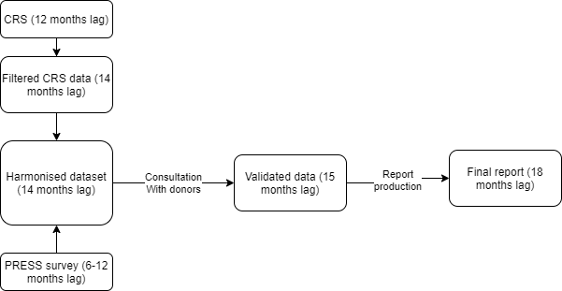

This lag meant that in its previous format (with the two data sources, as shown in Figure 2), PRESS could not provide relevant information for partners in data and statistics, including:

* Nowcasting the funding to statistics, i.e., estimating support to statistics and data for the current year.
* Forecasting funding to statistics, i.e., estimating support to statistics and data for the coming years.

Hence, despite the many improvements in PRESS over the years, the lack of timely aid reporting is a persistent concern among its primary users, especially the development aid providers. With a growing interest in supporting data and statistics, there is a growing demand for timely data to plan activities and projects and coordinate various development co-operation efforts. This issue has become particularly urgent in light of the coordinating efforts to fund the Cape Town Global Action Plan for Sustainable Development Data (CT-GAP),[4] as well as in the context of a diverse data ecosystem comprising new actors.

PARIS21 addressed this request in its 2019 annual meeting by introducing the concept of E-PRESS (or Early PRESS), which will provide stakeholders with PRESS-like information, with much less lag. This concept became more relevant in 2020, when the development co-operation community had to face the challenges that arose due to the COVID-19 pandemic in the national statistical system (PARIS21, 2020a) and funding to data (PARIS21, 2020b).

### Estimating up-to-date support to statistics using CRS

While the previous PRESS reports captured the support to data and statistics by looking at global **commitments[5]** to statistics, the annual **disbursements**[6] received by a certain country are also informative for donors when planning their activities, especially those short-term activities financed by a donor’s annual or biannual budget. Using this additional variable allows the estimation of funding to data and statistics received by countries in the current and coming years while still using the same base data*,* i.e., the CRS and PRESS surveys (and many other data sources on development aid), which include both variables for each project.

Looking at disbursements instead of commitments to estimate the support to data and statistics has two distinct advantages:

1. Disbursements capture the actual release of funds, so are more useful for donor planning purposes.
2. It can take several years to disburse a commitment. Hence, by design, there are more data points available on disbursements than commitments over the same time period. The additional data on disbursements allows for better understanding of financing patterns and donor behaviour, leading to more robust data analysis.

This availability of more data points enabled us to estimate support to statistics in the current year (nowcasting) through more robust regression analysis. It also provides more substantial evidence for the coming years (forecasting). The following sub-sections will focus on these estimates.

### Nowcasting: using commitments to predict current disbursements

Given that CRS has a lag of n-2 for reporting both disbursements and commitments, one way we can estimate support to statistics (i.e., now disbursements) in the current year is by looking at the relationship between the two variables. The literature on aid predictability indicates that these two variables may be closely related over time. A 2013 study examining aid predictability based on CRS data also shows that commitments have a significant impact on disbursements five years after they were made (Hudson, 2013).

For most development projects reported to the CRS and the PRESS survey, both commitment and disbursement data are reported. Even when these variables are not directly reported, however, the missing value can usually be imputed.[7]

Using these two variables, PARIS21 has developed a simple linear regression model to estimate the funding from donors based on historical data. Regression analysis was conducted to predict current disbursements based on reported commitments, captured by *Estimated_Annual_Spending*.

*Disbursement = Average_annual _spending * k + d*

Where *Average_annual_spending = Commitments/time*

This model shows a correlation between disbursements and average spending. Average annual spend is calculated based on the assumption that commitment without a detailed plan for disbursement will be distributed evenly by year, from the expected start year to the end year of the project.

The analysis of the two variables shows a significant correlation (90%) between disbursements and commitments each year. The value of k and the predictability of the model vary depending on the reporting pattern of each donor. For example, while the commitment numbers reported by most donors each year are usually higher than disbursements (Figure 3), this is reversed in the case of a few donors (Figure 4).[8]

Figure 3: Disbursements vs average spending reported in CRS

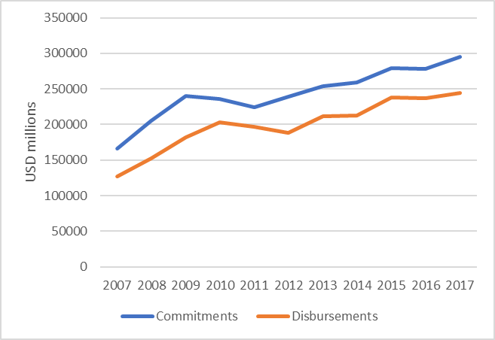

Figure 4: Disbursements vs Commitments in CRS reported by the UK

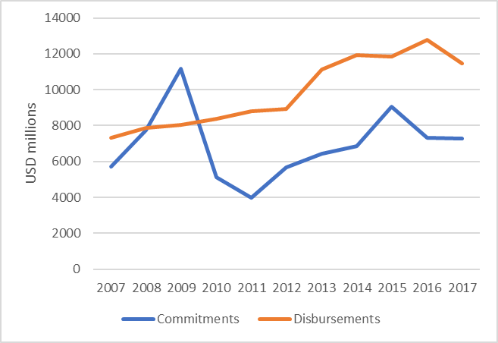

Using the above method, PARIS21 was able to nowcast the funding to statistics in years that the most recent CRS data does not fully cover. The estimated value can deviate from the actual reported number by 10-20%, and the accuracy is higher for more recent years as donors have committed to better transparency and reporting granularity.

Based on this methodology, although the CRS data available in early 2020 only includes full coverage of official aid until 2018, the nowcast is able to provide information on aid to statistics including 2019 and 2020. For the first time, the 2020 edition of PRESS presented information on funding to data and statistics to year *n-1.* [9]

### Forecasting: using assumptions to predict future disbursements

The predictability of disbursements and commitments used for nowcasting funding to statistics reduces greatly after the current year (or after a short time) since, for example, many projects which commenced in 2017 will end in 2020. However, this lack of predictability can be partially mitigated by the creation of a forecasting model based on a few well-informed assumptions, leveraging past PRESS data and PARIS21’s institutional knowledge on support to statistics for over two decades. These assumptions, which can lead to better forecast quality, are described below:

1. **Continuation of certain long-standing projects**: We can assume that large projects such as the support to the Demographic Health Survey driven by USAID, IMF’s national and regional training on economic statistics, and the World Bank’s programme on statistical development will continue in the near future. These projects are generally stable and attract similar spends each year. Likewise, the upcoming censuses or major surveys in low-income countries are expected to be funded partially by donors.[10] This information accounts for nearly half of the total amount for data and statistics. Confirmation from donors of the continuation of these projects can further improve the accuracy of this analysis.
2. **Termination or reduction of funding for certain projects**: We can also anticipate the termination or reduction for funding tied to a project based on its specific nature. For instance, the support for censuses is a one-off disbursement and will not reoccur until the next census round. Similarly, if a country graduates from World Bank’s IDA Borrower’s list or becomes an upper-middle-income country, it is then expected to receive a lower ODA grant and become illegible for some loans. In those cases, support for statistics might be affected disproportionally, given its low priority.

It is also crucial to state that these predictions can only be accurate if the following additional assumptions are met:

* Development aid providers maintain their current levels of effort
* Existing programmes continue to run
* Commitments are fully disbursed
* There is a response to prioritised needs such as censuses

The predictability of both nowcast and forecast also relies on aid providers committing to maintaining the transparency and timeliness of their aid data.

In addition, these forecasts should be interpreted with caution. Even if the above models indicate a significant increase in the coming years, the data and statistics community should not claim victory until this has fully materialised and the CT-GAP for Sustainable Development Data has been fully funded.

Due to the uncertainty caused by the COVID-19 pandemic, the forecasting results from this methodology were not presented in PRESS 2020. These will appear in the future PARIS21 publications once more evidence becomes available.

## Expanding the PRESS database

### Exploring alternative data sources for aid flows on statistics

Apart from nowcasting and forecasting disbursements to statistics from PRESS data, another way to address the structural lag in aid-flow reporting can be by investigating the root cause of the problem – the dependency on the CRS database – and searching for this information in alternative data sources. PARIS21 has identified three main (types) of alternative data sources below.

### The International Aid Transparency Initiative (IATI)

The IATI datastore is the largest alternative database outside of OECD-DAC data. With more than 100 donors reporting to this database, IATI has a much shorter lag than CRS. It also covers more projects by philanthropic foundations. The COVID-19 pandemic and the rising need for coordination has also incentivised aid providers to report to IATI with less delay. However, IATI data suffer from a lack of quality assurance and inconsistency within the dataset. Although it uses a similar data structure as the CRS, the reported projects in IATI may not include important granular information, such as the project description. Furthermore, as many donors only committed to reporting to IATI after 2014, the lack of historical data for drawing time series also affects its ability to forecast.

### Donors’ transparency portals

In recent years, global donors have strengthened their efforts in aid transparency. Many donors have developed online data portals or uploaded online datasets to share information on their aid projects, especially the major donors in statistics such as the World Bank, UNDP, USAID, DfID, Canada, etc. These datasets usually have a similar density of information as the CRS data and are usually updated more frequently than CRS. However, the majority of donors still lack appropriate portals and public datasets. Furthermore, merging these different datasets is possible, but time intensive.

PARIS21 has been exploring these data sources since 2019 and has accumulated knowledge over this period. For example, the USAID dataset helped PRESS 2019 to identify the USA’s support to statistics for the first time; in particular, its effort with the Demographic Health Survey (DHS). PARIS21 has also established a methodology for merging and harmonising the aforementioned datasets. The methodology maps variables in different datasets against each other and uses internal project identifiers to avoid duplications.

### Multilateral donors’ prospective reporting to the PRESS survey

The online PRESS survey (introduced in section I) includes a feature that allows donors to report on future projects. Since many donors have a biannual programme of work, in each year’s survey, they are encouraged to provide information on the project they have planned or committed to in the near future. In the survey, donors can verify, edit, and cancel future projects in the next round of reporting. However, previous PRESS reports did not fully reflect future projects due to their focus on accuracy. However, these could still contain valuable information to assist in the projection of aid flows. The methodology developed by PARIS21 leverages this as an underutilised existing data source that may not reflect completely on the activities from donors. Nevertheless, it is useful for nowcasting the funding.

The comparison of the above data sources can be found in Table 1. As another important data source in the area of data and statistics, the Eurostat’s donor survey is analysed in Box 2.

Table 1: Comparison of data sources

|  |  |  |  |
| --- | --- | --- | --- |
| Data source | No. of observations | Advantages | Disadvantages |
| Conventional data source | | | |
| CRS | More than 2.5 million | * Full coverage of donors’ portfolios (as long as projects are counted as ODA) * Data quality assured by the WP-STAT[11] standards | * 12-month lag * Relatively low coverage in multilateral organisations and NGOs * Needs further analysis to identify statistics-related projects |
| Alternative data sources | | | |
| PRESS survey | 4000 to 5000 | * Only statistics- or data-related projects are included * Allows reporters to enter future planned projects | * Only covers key multilateral donors in statistics * Detailed information may be omitted by reporters during the reporting process |
| IATI[12] | More than 500,000 | * A small lag in reporting * Reporting from NGOs and philanthropic foundations * Gradually gaining popularity among aid providers | * Needs further analysis to identify statistics-related projects * Lack of quality assurance * Incomplete portfolio |
| Donors’ transparency portals | The full portfolio for each donor | * Full coverage of donors’ portfolios * Well maintained and updated | * Fewer than ten major donors provide accessible databases * Needs further analysis to identify statistics-related projects |

Box 2: The Eurostat’s Donor Survey – and why it is not included in the PRESS database

The annual Donor Survey by Eurostat aims to provide an overview of statistical projects in the respective countries to allow for better planning of assistance in the field of statistics, to benefit from acquired experience, and to avoid overlap. The survey is distributed to donor countries, international organisations, and the recipients (mostly Eurostat member states or partner states) of support to data and statistics.

According to the report of the 2020 round, the Donor Survey’s main objectives included:

* facilitating better planning and prioritisation of assistance, especially amongst the donors;
* increasing transparency/visibility for donors and implementing agencies and potentially serving as an “audit” document for beneficiaries;
* providing the beneficiaries with a broad overview of the areas in which they are receiving support, also at regional level, and prioritising their future needs;
* benefitting and learning from the experiences, good practices, and shortcomings of other projects;
* facilitating a dialogue between beneficiaries, donors, and implementing agencies.

At donor country level and on the donors’ side, respondents to the Donor Survey overlap with CRS. However, the CRS reporting is coordinated by one national focal point, while the Donor Survey questionnaire is distributed to both the aid agencies and national statistics offices who provide technical support. However, the Donor Survey dataset does not have a good system to harmonise the data from the two sides, nor does it contain the programme identifiers, which are essential to avoid duplication when combining information with other sources. Unlike the development of financing databases, the Donor Survey also lacks a mechanism to update previous years’ reported projects. Coverage of the survey is also not comprehensive enough to provide additional values to the alternative data sources identified in this document.

Because of these reasons, the Donor Survey data are currently not included in the extended PRESS database.

### Addressing gaps in the alternative data sources

To take advantage of the alternative data sources, PARIS21 combined the information from CRS and online surveys with these alternative data sources to create a more up-to-date, harmonised database on funding for data and statistics. However, this means that there is a requirement for the completeness and coverage problems to be addressed, as described below:

**1) The completeness problem:** A common weakness of the alternative data sources, compared with CRS, is their incomplete coverage. This is especially apparent in IATI where, unlike CRS, donors may not report their full portfolio, leading to a lack of comprehensive information (vertical). Furthermore, the CRS uses a more “centralised” reporting system for each donor country, whereby information from different agencies providing ODA is gathered under one entity before reporting to CRS as a whole. The IATI, on the other hand, allows different agencies in a single donor country to report their data separately. This implies different reporting patterns for different agencies based on their capacity to do so regularly, and a lack of overall coordination.

**2) The coverage problem:** CRS contains information from over 100 donors. On the other hand, donor transparency portals suffer from a “horizontal” problem, i.e., they usually have complete coverage and contain the full portfolio, but fewer than ten major donors provide access to such open and easy-to-use databases.

PARIS21 has mitigated the horizontal and vertical problems in alternative data sources by harmonising and linking these databases. The final dataset used in the analyses below combines the alternative data sources and PRESS data using project IDs and other identifiers. As a caveat, however, the total number of projects included in the alternative sources still only represents 40% of all projects reported in the CRS.

The advantage of using such data sources, such as the timeliness and inclusion of philanthropic foundations, makes them a useful extension of PRESS data, especially when trying to solve the lag issue. However, their weaknesses imply that they are not a substitute for CRS or, by extension, conventional PRESS reporting.

### Linking the alternative sources: the new harmonised database

The next step in leveraging the independent alternative data sources described above is to link them with PRESS data and create a new harmonised database of disbursements for data and statistics **at project level**.

Using disbursements as the primary variable to determine the support to statistics is even more beneficial at this stage, and data on annual disbursements is adequately available in most of the sources considered above. The activity-based CRS data, for example, contain disbursement information for more than 98% of the projects. Similarly, the PRESS survey for multilateral donors provides specific information on disbursement plans (though it is project-based). The donors’ transparency portals are also expenditure/disbursement based.

However, the IATI database is weaker in this regard: it contains an unusually high percentage of negative commitments or disbursements. For example, in 2016, 18% of projects reported either having negative commitments or disbursements, while this was less than 1% for CRS.[13]

For the harmonised database, the missing disbursement values were inputted based on the assumption that the commitments were distributed evenly from the start date to the end date of the project. These negative projects in IATI were corrected or removed by cross-validating against CRS. The duplicated projects were then removed based on project identifiers. Consultations with several multilateral donors were conducted to ensure the validity of the final data.

Figure B.4 presents an example of how the new harmonised dataset looks after linking the different sources. For the 15,312 projects in the new datasets, 54% of disbursement activities come from the CRS data, compared with over 73% in the earlier dataset used for PRESS. In the new dataset, the PRESS survey accounts for 27% of projects, while IATI data and donor databases account for 19% of projects. By filtering through the data using recipient country and year, donors can already observe the upcoming funding received by a country for statistical development. It is then easier for them to identify funding gaps in prioritised areas. Hence, the new harmonised database can achieve better diversification of data sources and reduce the dependence on CRS.

Figure 5: Comparison of PRESS and the new harmonised database for the share of projects in the final datasets, by sources of data

### Bringing them together – nowcasting and forecasting with the new harmonised database

PARIS21 applied the same model on nowcasting and forecasting support to statistics (disbursements) but based on the new harmonised database, linking PRESS data with the aforementioned alternative sources. The main findings of this approach were similar to those based on CRS estimations: there is no indication of a systematic increase in funding to statistics in the current or coming years.

## Conclusion

The nowcast and forecast analysis aims to solve the specific lag issue faced by the PRESS, rather than to substitute it. Even with longer lag, PRESS still reports the most reliable and comprehensive data on funding to statistics. The PRESS database continues to serve as the source data for SDG Indicator 17.19.1.

The outputs from nowcast and forecast also vary in their accuracy. While the merged database is as robust as PRESS, the forecast analysis is based on several assumptions. Results produced through the nowcast and forecast analyses can therefore be used for different products to serve different purposes:

* The nowcast on disbursements and some information provided by the harmonised dataset can be directly presented in PRESS 2020 as a natural extension of its current content, based on existing data sources such as CRS.
* The forecast for funding gaps could be presented in separate policy briefs due to its speculative nature.
* The complete, harmonised database can also be deployed on a platform to be used as a dynamic planning tool by development partners.

The immediate next step in improving the new methodology is to strengthen the communication and consultation between PARIS21, donors, and recipients. Benefits from such consultations would lead to further robust results by correcting erroneous information contained in IATI data, validating assumptions on the termination or continuation of projects in assumptions for forecasting, and enhancing data sharing in general. Consultations over the product will also help PARIS21 to shape its work in order to better meet the demand of its stakeholders.

As the COVID-19 pandemic may affect donors’ GDP/GNI and, consequently, their ODA, some fluctuation in development financing can be expected. Despite the difficulty these anomalies will bring to the analyses, however, the transparency and timeliness of the information on funding to data and statistics have also become more relevant, as identified in Part I of PRESS 2020. The results from these analyses can play a crucial role in informing and supporting the statistics and development co-operation communities in their response to these challenges.

Table 2: The sub-dataset of each Figure in PRESS 2020

|  |  |
| --- | --- |
| **Figure number and title** | **Sub-dataset used** |
| Figure 1. Share of statistics-related projects in development aid addressing COVID-19 | Data are downloaded from the d-portal of IATI and aggregated through it. |
| Figure 2. Funding to statistics and data from external sources has been stagnant since 2014 | The entire dataset aggregated by year and the projection for 2019 is based on nowcasting of projects. |
| Figure 3. Total number of censuses planned, by region | Data from UNFPA. |
| Figure 4. How do donors decide on supporting data and statistics? | This figure is directly from another publication. |
| Figure 5. DAC members’ views on topic data availability, levels of funding, and coordination | This figure is directly from another publication. |
| Figure 6. Global commitment to statistics | Same as figure 2. |
| Figure 7. Share of alignment with national statistical plans, sectoral vs non-sectoral programs | Projects that are not marked by reporters for alignment with the national statistical plans or are not marked by reporters for their sector/systematic nature, are not included in the calculation. Systemic projects aim to improve the capacity of the statistical system, such as the IADB’s programme to strengthen the statistical capacity of Argentina’s national statistical system. Sectoral projects in the figure are defined as projects with a sectoral focus and aim to provide sectoral data, such as sectoral survey programmes. |
| Figure 8. Sectoral distribution of funding to COVID-19-related projects that also have a gender statistics dimension, August 2020 | Only projects that are related to COVID-19 and have an explicit gender dimension are included in the calculation. The sectors defined in this figure are based on the sectors defined in CRS. The total amount represented by the pie chart is 28 million USD. |
| Figure 9. Share of DAC donors’ statistical projects targeting gender equality, 2018 | This figure only includes data and statistics projects reported in the CRS database with a gender marker. The total amount represented by the two pie charts are 829 projects (left) and 436 million USD (right). |
| Figure 10. Share of DAC donors’ commitments for gender statistics activities, identified from text mining in 2011-2018 | This figure only includes data and statistics projects reported in the CRS database. The gender component is identified mainly through text mining or validation from donors on the gender component. The denominators of the percentages in this figure are the three-year rolling average of total funding to data and statistics, e.g., 693 million USD in the year 2018. |
| Figure 11. Share of the top 5 and the rest of the donors for gender statistics activities in 2018 | This figure only includes data and statistics projects reported in the CRS database. The gender component is identified mainly through text mining or validation from donors on the gender component. The total amount represented in the figure is the funding for activities, of which gender is the primary component (51 million USD) in Figure 10. |
| Figure 12. Share of multilateral donors’ projects which refer to gender statistics, 2018 | This figure only includes data and statistics projects reported to the PRESS survey conducted by PARIS21. The gender component is identified by reporters to the survey. The total amount represented by this pie chart is 884 projects. |
| Figure 13. Multilateral donors’ project themes containing activities around gender statistics, 2018 | This figure only includes data and statistics projects reported to the PRESS survey conducted by PARIS21. The total number represented by the square is the total funding allocated to gender statistics in those projects. The gender component is identified by reporters to the survey. The total amount represented in this figure is 18 million USD. |
| Figure 14. Country-specified vs unspecified support to data and statistics since 2007, three-year rolling average | This figure only includes projects marked with areas of statistical activities. |
| Figure 15. Areas of statistical activities most targeted by aid to data and statistics, three-year rolling average | This figure only includes projects marked with areas of statistical activities. |
| Figure 16. Funding to data and statistics by region, three-year rolling average | The whole dataset aggregated by region. |
| Figure 17. Share of top 5 and top 25 recipients in funding to statistics since 2007, three-year rolling average | The total amount represented in this figure is the three-rolling average of total commitment to data and statistics, e.g., 693 million USD in the year 2018 |
| Figure 18. Statistical capacity and support to statistics compared, 2016-2018 | SIDS are removed in this process because the per capita funding they received can increase significantly due to their small populations, even though only small amounts were received. |
| Figure 19. Small island developing states with more than 1 million USD in commitments to data and statistics, 2018 | The total amount presented in this figure is calculated by totalling the projects that are dedicated to SIDS. Only country-specific projects are included in the process. |
| Figure 20. Top 5 and the rest of the donors in data and statistics for small island developing states, 2016-2018 | The total amount presented in this figure is calculated by totalling the projects that are dedicated to SIDS. Only country-specific projects are included in the process. |
| Figure 21. Top 5 and the rest of the fragile state recipients in support to data and statistics, 2018 | The total amount presented in this figure is calculated by totalling the projects that are dedicated to fragile states only country-specific projects are included in the process. |
| Figure 22. Top 5 and the rest of the donors committed to data and statistics in fragile states, 2018 | The total amount presented in this figure is calculated by totalling the projects that are dedicated to Fragile States. Only country-specific projects are included in the process. |
| Figure 23. Top 10 and the rest of the donors to data and statistics, 2016–2018 | The whole dataset aggregated by donors. |

# References

CCSA. (2020). *How COVID-19 is changing the world: a statistical perspective. Volume II.* CCSA. Récupéré sur https://unstats.un.org/unsd/ccsa/documents/covid19-report-ccsa_vol2.pdf

Hudson, J. (2013). Promises kept, promises broken? The relationship between aid commitments and disbursements. *Review of Development Financ2*, 109-120. doi:https://doi.org/10.1016/j.rdf.2013.08.001

PARIS21. (2020a). *Combating COVID-19 with data: what role for National statistical systems?* Paris: PARIS21. Récupéré sur https://paris21.org/sites/default/files/inline-files/COVID_Policybrief_Full.pdf?v=2.0

PARIS21. (2020b). *Partner Report on Support to Statistics 2020.* Paris: PARIS21.

UNFPA. (2020). *Technical Brief on the Implications of COVID-19 on Census.* New York: UNFPA. Récupéré sur https://www.unfpa.org/sites/default/files/resource-pdf/Census_COVID19_digital.pdf

1. Until 2019, this purpose was vaguely defined as “Both in national statistical offices and any other government ministries”. However, after a successful campaign to improve the description, this purpose is now defined as “All statistical activities, such as data collection, processing, dissemination and analysis; support to development and management of official statistics including demographic, social, economic, environmental, and multi-sectoral statistics; statistical quality frameworks; development of human and technological resources for statistics, investments in data innovation”.
2. Eligibility for IDA support depends first and foremost on a country’s relative poverty, which is defined as GNI per capita below an established threshold and updated annually ($1,185 in the fiscal year 2021). IDA also supports some countries, including several small island economies, that are above the operational cut-off but lack the required creditworthiness to borrow from the International Bank for Reconstruction and Development (IBRD). For more information, see: <http://ida.worldbank.org/about/borrowing-countries>
3. Previously, the coverage throughout the report shows inconsistent changes between all IDA countries and all developing countries.
4. See https://unstats.un.org/sdgs/hlg/Cape-Town-Global-Action-Plan.
5. A firm obligation, expressed in writing and backed by the necessary funds, which is undertaken by an official donor. It provides specified assistance to a recipient country or a multilateral organisation. Bilateral commitments are recorded in the full amount of the expected transfer, irrespective of the time required for the completion of disbursements. Commitments to multilateral organisations are reported as the sum of (i) any disbursements in the year reported on, which have not previously been notified as commitments, and (ii) expected disbursements in the following year.
6. The release of funds to or the purchase of goods or services for a recipient; by extension, the amount spent. Disbursements record the actual international transfer of financial resources, or of goods or services valued at the cost to the donor. In the case of activities conducted in donor countries, such as training, administration, or public awareness programmes, disbursement is assumed to have occurred when the funds have been transferred to the service provider or recipient. These may be recorded as gross (the total amount disbursed over a given accounting period) or net (the gross amount, less any repayments of loan principal or recoveries on grants received during the same period). It can take several years to disburse a commitment.
7. For example, the amount for technical support projects that do not have direct monetary transfers can be replaced by a cost estimate by the provider. In cases where the disbursement information is missing, the estimated disbursement amount can be calculated by dividing the unspent commitment amount using the number of years left before the expected end date.
8. This particular reverse correlation can be explained by different factors. Firstly, the financial crisis impacted the continuity of some donors’ ODA flow more than others. The significant variation of the exchange rate or inflation rate of a donor could also lead to a sudden change in the converted constant value of aid. In addition, some donors tend to make more long-term commitments than others, resulting in a distribution of disbursements over a long period of time, even after the donors had significantly reduced their overall international aid package.
9. Due to the disruptive effect of the COVID-19 pandemic on the predictability of the model, the nowcasting results for 2020, although produced, were not presented in the PRESS 2020 report.
10. The COVID-19 pandemic has brought great uncertainty to this assumption, especially for censuses planned to take place between 2020 and 2021. Although funding for most censuses has been secured, many countries have diverted their national budget to other, more urgent matters (CCSA, 2020) (UNFPA, 2020), resulting in the postpone of external funding.
11. DAC Working Party on Development Finance Statistics, see <http://www.oecd.org/dac/financing-sustainable-development/development-finance-standards/wp-stat.htm>
12. See <https://iatistandard.org/>
13. Based on data collected in 2019, the future improvements of the database may resolve this issue.